Roadmap for Doctor Appointment ChatBot

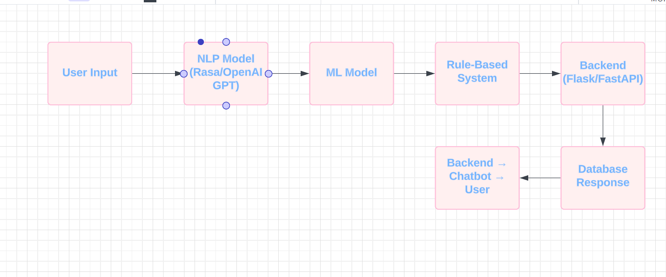

Link to roadmap: <https://lucid.app/lucidchart/7768f722-030c-46c7-af5c-13d36b27aac4/edit?viewport_loc=-72%2C-32%2C1364%2C551%2C0_0&invitationId=inv_c78bae0b-69e6-48ec-bb20-17e8ea62851f>